PROFILE OF USADEC
- Registered at national and or district level: a minimum of 19 years’ operating in area of intervention and recognized as an active member of JADF
Organisation légal Name: Union de Solidarité d’Aide au Développement Communautaire |  |  |  | Short Name: USADEC
Type of Organisation: NGO
Recognized as an active member of JADF: Rutsiro, Rubavu, Rusizi, Karongi, Bugesera and Nyarugenge Districts
RGB registration number (Registered at national level): 58/8.11  Date of registration: 2012 |  |  | Date of creation of organisation: 2003  Month/year of first project implementation: 6/7/2004
Telephone: +250 788642109  Whsap: +250 787440533 | Fax: N/A | Mailing address: PO Box: 3441 Kigali-Rwanda
Street address (if applicable): N/A
General E-mail Address: usadec19@gmail.com Website:http://usadecglobal.org is under construction
Location of main offices (enclose diagram with directions)
Sector: Remera
District: Gasabo
Province: Kigali City
Country: Rwanda
Name of main contact person: MAHORO R. Alexis
Function of main contact person: Executive Director
Phone:(+250) 788642109
Email: usadec19@g mail.com
Name and positions of senior staff:
- MAHORO R. Alexis – Executive Director
- WYVINE UWIMANA – Human Resources Manager
- RUBAYIZA Jean Batiste – Program Manager
- BISAMA Desire – Financial Manager
Personnel (specify number of men and women in each category)
Board of Trustees/Directors and their composition:…2 men 3 .women
- MAHORO RUBIBI ALEXIS - Male, CEO .
- KABANYANA Noriet- Female, 1st Vice-President.
- Nana NABINTU - Female, Secretary.
- Antoinette NYIRABAGIRO - Female, 2nd Vice President.
- MURWANASHAKA EVARISTE - Male, Advisor to the Board
The Board members and Board Charter
- Number of senior staff members: 2 men 5 women
- Number of permanent salaried employees: 1 men 2 women
- Number of volunteers: 10 Men 17 women

- Proven track record in civic engagement, policy analysis and advocacy
List your top donors in 2017-2022 and amounts secured in USD:
Year Funds received | Name of Donor | Amount | Projects
2024 | NAR | USD 66000 | Strengthening Civic participation in the prevention and resolution family conflict of Rusizi district
2023-2024 | RGB/UNDP | USD 55,000 | Eradicating Malnutrition of vulnerable children in Mukura and Mushubati Sectors of Rutsiro District, Western Province
2023-2024 | RCCDN | USD 105,000 | Community campaign on waste management
2019-2022 | GF-HIV | USD 350.000 | Fighting HIV/AIDS and support people affected in income generating activities
2019-2020 | EABN/EAST AFRICAN BUDGET NETWORK | 54000 USD | Advocacy on Civic participation in National budget process
2020 | The Canada Fund for Local Initiatives (CFLI) | USD36,000 | Eliminating Child Labor on Tea Plantations

3. Demonstrated experience in areas relevant to economic transformation, social transformation or transformative governance
a. Child Rights
USADEC ensures child rights through rights provision, protection and participation. USADEC uses Children Groups as a recreational and learning forum. Children are encouraged to open up and share with other children of the same age group their experiences in everyday life through child to child interaction. At this level, children are sensitized about their rights and issues identified at this level are taken up to the Cluster Level Association (CLAs) and other Duty Bearers.
b. Integrated Early Childhood Development (ECD):
The program seeks to address the children’s needs in a holistic manner (Photo of school feeding). Through an integrated approach, USADEC empowers and supports community efforts for setting and running community based Early Child Development centers with an aim to provide all children with stimulation and care in the early years.
c. Basic Education
USADEC focuses on increasing access to basic education as well as improving the quality of education. The key components of this program include classroom construction, provision of equipment’s and instructional materials, sport and sanitation facilities, teachers training programs and training school management committees.
d. Adolescent Sexual and Reproductive Health
The program focuses on strengthening the capacities of in and out of school youth on sexual, reproductive health, prevention of HIV Sexual Transmitted Infections, teenage pregnancies and life skills. The trained youth are grouped in clubs which in turn sensitize the community on adolescents’ sexual reproductive health and rights.
e. Youth empowerment program
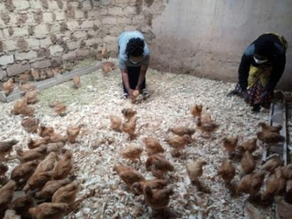
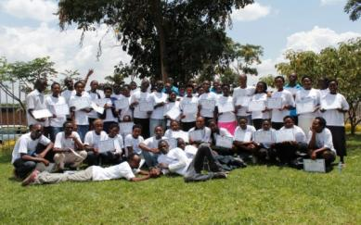
The programs seek to empower vulnerable youth to access employment and income through rural Technical Vocational Education and Training (TVET), Agriculture and Vocational Training (AVET), Job & Business Services (JBS), and community based training (CBT). Based on market survey and need assessment, youth are guided to make the right choices with greater impact. They are also linked with government structures, Microfinance Institutions, People Institutions and potential markets.
f. Women transformation
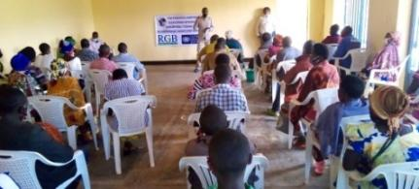
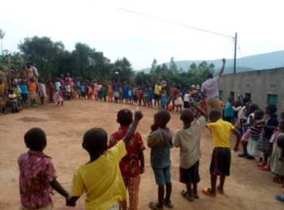
The program aims at supporting vulnerable women for increased access to nutritious food for household in the interest of a child. This is achieved through the promotion of kitchen garden, fruit trees planting and small livestock farming to fight child malnutrition.
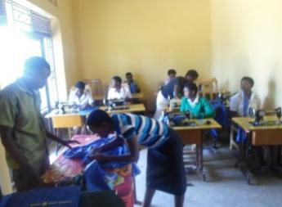
g. Wast management
The program aims to strengthen community capacities on
the collection of domestic waste; the separation of
biodegradable and non-degradable waste and
Their deposit in the appropriate places.
It also aims to mobilize actors from the private sector to
invest in the recycling of domestics waste
The program ‘s activities aim at the fight against pollution and
climate change as well as promotion of community hygiene 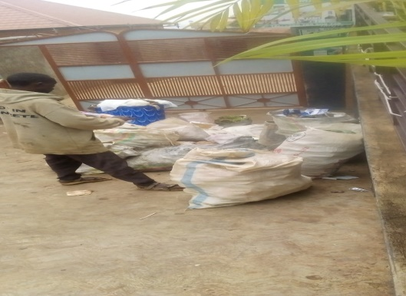 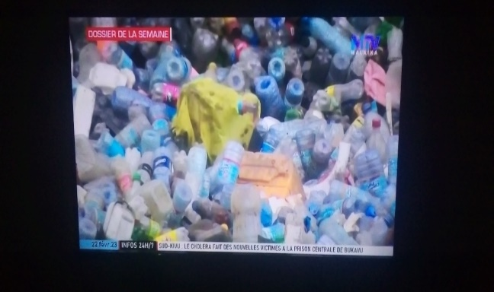

Examples of projects USADEC has implemented in least 4 years contributing to the NST1 process
Project title: “Twiyubake” renforcement des personnes handicapes of Rutsiro district
Donor: RGB /UNDP
Total budget: USD 55000
Start date: 04/2023
End date: 05/2024
Project Location: Mukura and Mushubati Sectors of Rutsiro District, Western Province

Project Objectives:
Its objective is to contribute to the promotion of sustained economic growth, and productive employment and decent work for people with physical disabilities.

Target population(s):
100 households of Mukura and Mushubati sector of Rutsiro district with malnourished disabled children (girls and boys) who are growing abnormally.

Key Interventions:
- The project staff has been put in place, in particular the coordinator and the accountant
- The project was officially introduced to local authororities at district and sector level which enabled their active participation in the implementation and monitoring and evaluation of activities and the success of the project
- 100 vulnerable people with physical disability including 53 women and 47 men, were selected in collaboration with local authorities at cell and village level according to pre-established criteria.
- 100 direct beneficiaries were organized into 4 VLSA groups (savings and credit group), they were trained in modern breeding techniques for laying hens and the development of vegetable gardens
- The beneficiaries were supported in the construction of 100 chicken coops and1000 breeding laying hens were distributed to them due to 10 laying hens per beneficiary as well as veterinary products (drugs and vaccines) and concentrated feed.
Any key innovation:
- USADEC initiates community development by bringing together beneficiaries and different actors through our well-known principle: ’if you give me a fish I will eat one day but if you teach me how to fish I will always eat’ on my own ’’
Major achievements/impact to date:
- Due to the breeding of laying hens and the development of vegetable gardens, the incomes of people with disability have been increased, their nutritional status and their living conditions have been improved because a part of the eggs and vegetables produced has been consumed and another has been sold at local market
- The land productivity has been improved due to the manure of the hens and the agricultural yield has been increased to alleviate food insecurity and poverty
- The community and particularly households having people with disability are more sensitive to respect their fundamental rights and no marginalize or discriminate them and the delivery services are good quality
- People with disabilities have self-confidence to enjoy and claim their basic rights
- All 100 direct beneficiaries have health insurance (mituel de santé) and their access to health care is improved
- The direct beneficiaries are grouped into 4 VLSAs in order to save and actually they start granting credits which has allowed them to start doing other business such as goat breeding, milk trade, fruit and vegetable trade, etc... ..
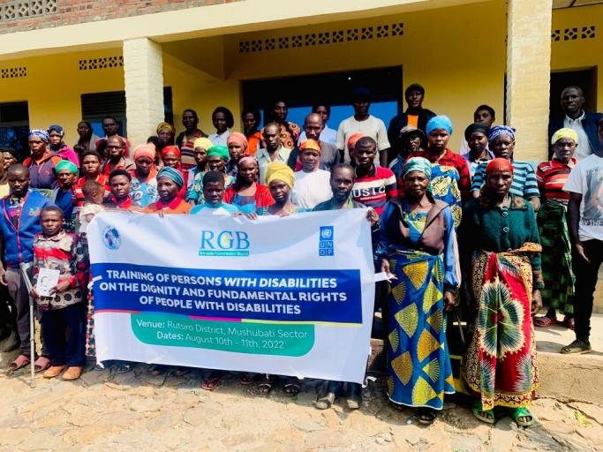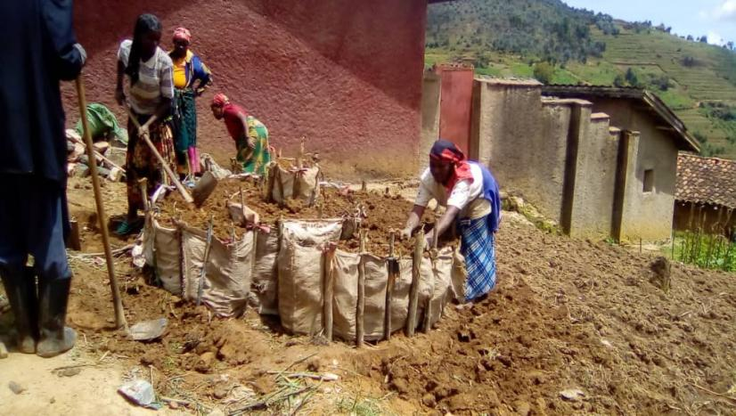

Project title: Community Education on rational waste management
Donor: Rwanda Climate change Development Network (RCCDN)
Total budget: USD 105,000
Start date: 5/03/2023
End date: 11/04/2024
Project Location: City of Kigali

Project Objectives: To fight air pollution and climate change , hygiene and sanitation
Target population(s): People of GASABO District, waste collection companies

Key Interventions:
- Awareness campaigns
- Training :
- Community dialogues
- Support in hygiene materials

Major achievements/impact to date:
12 community awareness campaign on domestic waste collection were done
Training of 500 community animators from 12 sectors of GASABO District
12 community dialogues were done
Impact
Domestic waste is regularly collected and deposited in the appropriate places
the community separates degradable and non-degradable waste
air pollution is reduced and community hygiene is improved
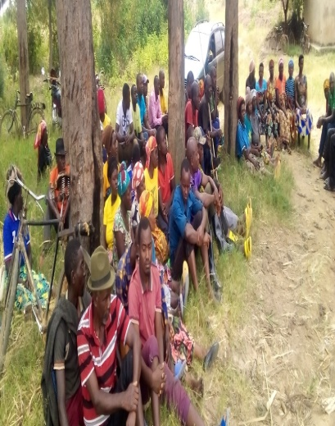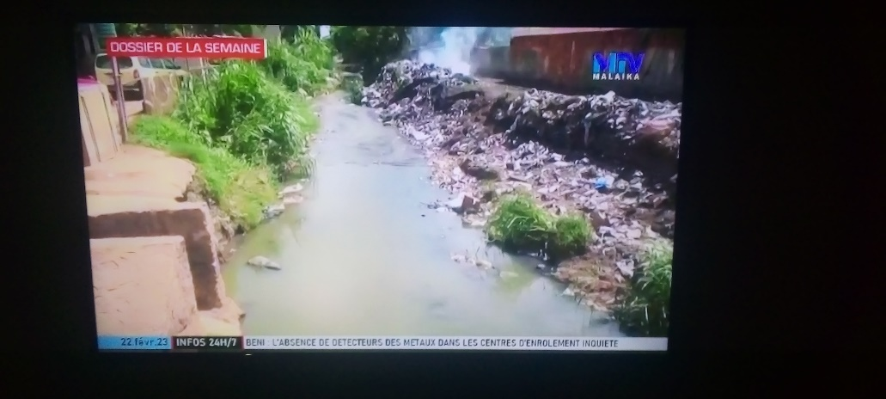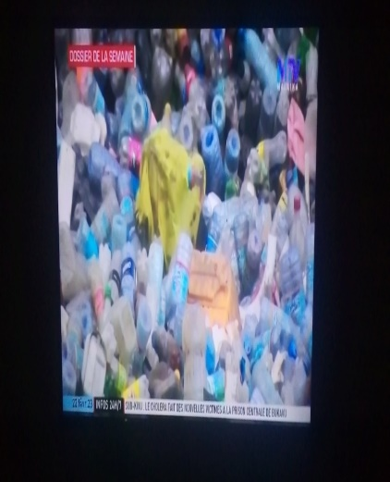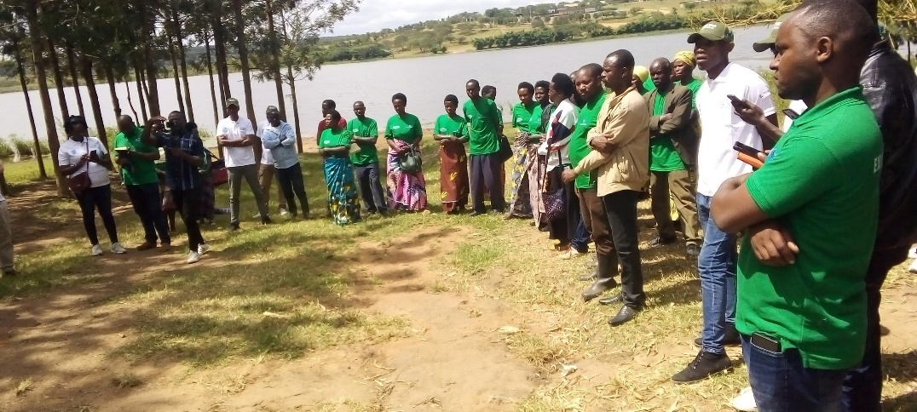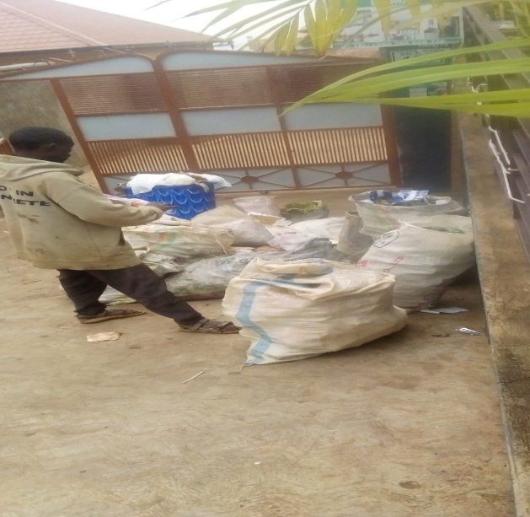

Project title: Inspiring and empowering 100 Vulnerable Women
Donor: Global Giving
Total budget: USD 37,000
Start date: 10/10/2016
End date:10/02/2019
Project Location: 4 Villages (Ruharambuga, Kagano, Bushekeri and Karengera) in Nyamasheke District
Project Objectives: To inspire and empower 100 Vulnerable Women
Target population(s): 100 Vulnerable Women
Key Interventions:
- Financial capital to start small - quick turnover - businesses enabling them to improve their income;
- Psychosocial support, especially trauma counselling; and
- The national education policy and child right and child labor.
Any key innovation:
- USADEC initiates community development by bringing together beneficiaries and different actors through our well-known principle: ’if you give me a fish I will eat one day but if you teach me how to fish I will always eat’ on my own ’’
Major achievements/impact to date:
- All beneficiaries now participate in income generating activities. As a result, many are now able to buy medical insurance and basic necessities for themselves and their families.
- Furthermore, the women are now able to pay for the school fees, making it possible for their children to attend school, instead of being engaged in work such as on the tea plantations in the area.
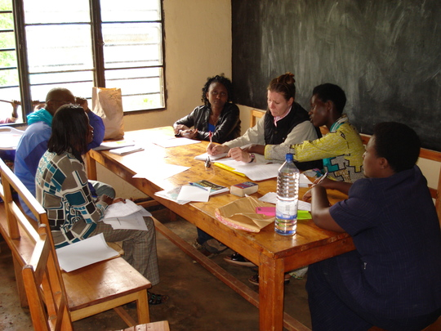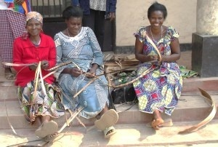

Psychosocial support (trauma counseling) Training for the jewellery making and hand craft

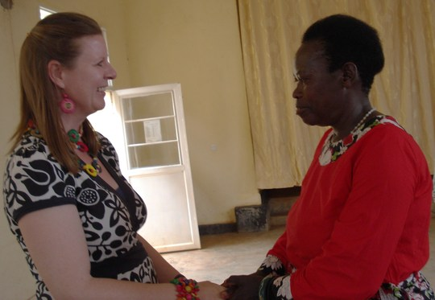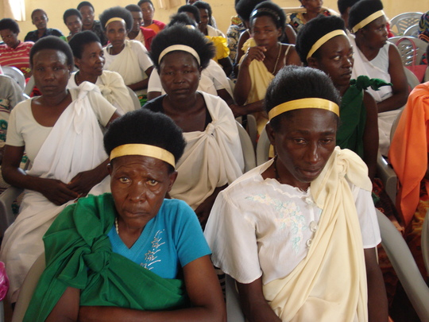

Ceremony to receive startup capital

Project title: Eliminating gender based violence
Donor: The Canada Fund for Local Initiatives (CFLI)
Total budget: USD 36,000
Start date: 11/08/2019
End date: 30/07/2020
Project Location: Burera District

Project Objectives: To eliminate violence against women
Target population(s): Vulnerable women

Key Interventions:
- Establishment of 20 clubs in each sector comprising of 20 women each.
- The clubs provided the woment with:
- Women were provided with start-up capital and were trained in various income generating activities such as tailoring, welding, painting and carpentry, so that they can provide for themselves and their families.
- Lastly, given that many of the women are affected by HIV/AIDS, health education was also provided on living with HIV/AIDS and how to prevent transmission.

Major achievements/impact to date:
Those women participated in the training on income generating activities either started their own local businesses or are employed in different organizations. The income generated through their various activities is now used to pay for health insurance and basic necessities, as well as to support their families.
The this outcome has in turn contributed to reduced violence in their families.
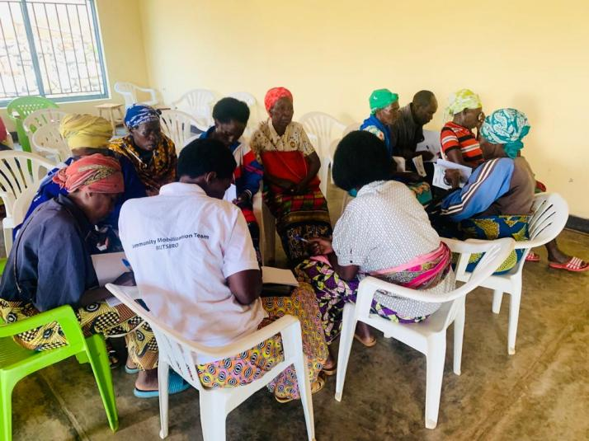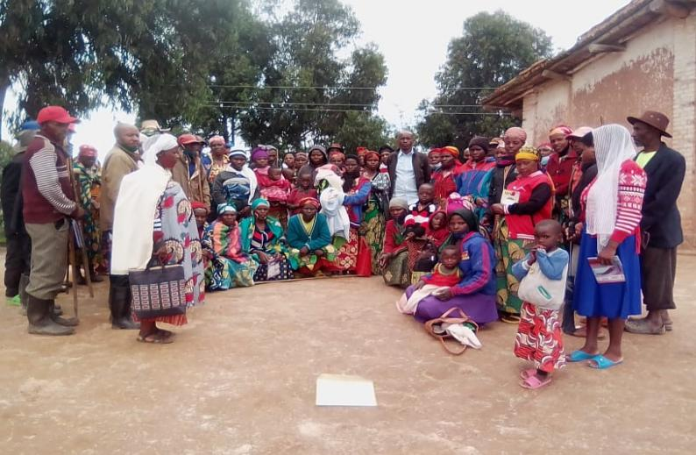
Project title: Fighting HIV/AIDS and support youth affected in income generating activities
Donor: Global Fund
Total budget: USD 350,000
Start date: 07/02/2018
End date: 30/11/2018
Project Location: Kicukiro , Nyarugenge and Nyamasheke Districts
Project Objectives: To empower uneducated youth with TVT.
Target population(s): Uneducated youth
Key Interventions:
- The 300 women youth selected to participate in the program received training in computer literacy, computer maintenance , repair, photography, movie shooting and music technology – in rural Area we train Them in Welding, Carpentry, Painting, Construction, Tailoring all areas selected based on the current gaps in the job market in Rwanda.
- As a result of completing the training, the students are now interning with different public and private organizations, providing them with the opportunity to be obtain a job afterwards. Now, the salary of the students per month range from $150 to $350$ which they use to pay for their school fees and support their families.
Major achievements/impact to date:
300 women youth that have not completed secondary school and who live in absolute poverty with work readiness and hands-on training (including entrepreneurial and financial skills) so that they can access employment opportunities.
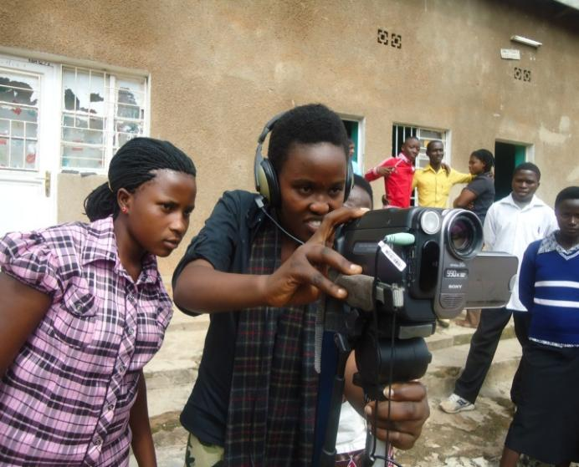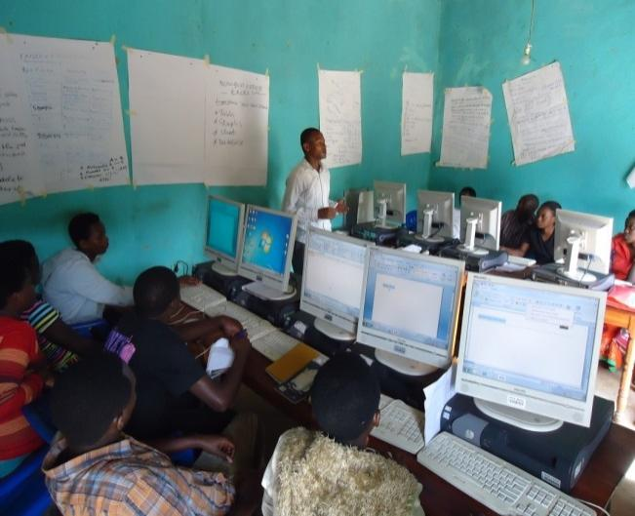

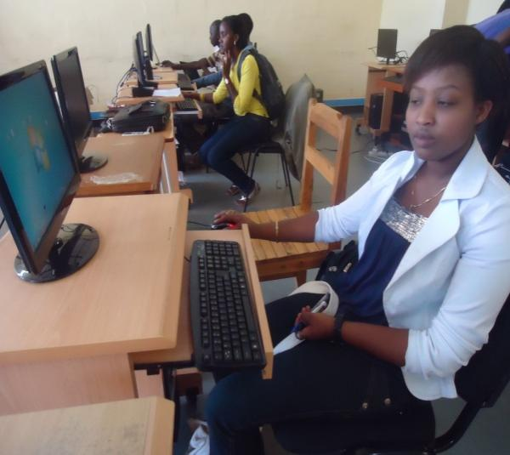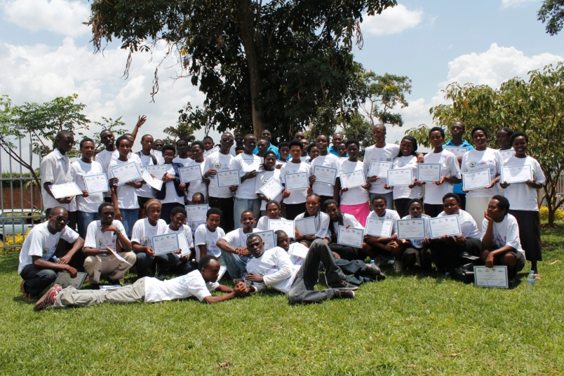

4. Track record of credible, transparent, ethical and impactful interventions in Rwanda; experience in multi-stakeholder coordination is desirable (Copies are available at the office)
- Valid RGB Registration Certificate
- Organization Chart
- Recent Organization Annual Report
- Finance & HR/Administration Manual
- Procurement policy
- Anti-fraud Policy
- Safeguarding policy
- Travel policy
- Organization Financial Statement Audit and management letter (Last 2 years)
- Experience of working with International NGO, donors - 3 Letters of reference
- RSSB Clearance certificate (less than 3 months)
- RRA Clearance certificate (Less than 3 months)
- Experience of working with International NGO - 3 Letters of reference

5. Inclusion and non-partisanship: Interested organisations must be gender-inclusive
1. INTRODUCTION
The owner of the project is "Union de Solidarité d’Aide au Développement Communautaire" (USADEC). This organization was created in 2003 by eight members (8) including five women and three men with mission of promoting social-economic conditions of the population through income generating activities, capacity building reinforcement of beneficiaries and coaching. USADEC operates legally in Rwanda with legal personality no 58/8.11 and collaborate closely with Ministry of local government and operating districts.
Staff Structure
Starting with a core team of 3 staffs in 2004, USADEC increased the number of its staff up to 8 full time staff and 32 community volunteers in the beginning of 2022. The Executive Director, Mahoro ALEXIS, is responsible for the facilitation of organizational growth as a team leader and participates in project planning, monitoring and represent organization. He is instrumental in policy advocacy and liaison, agency policy and strategy change management; and head the project quality development cell. Executive Director is assisted by Programme Manager, Bisama Desire; Financial Manager, JMV Rucyahanyiko and Human Ressource Manager, Viviane Uwimana.
Board of Directors of USADEC
In terms of management, USADEC has a Board of Directors which oversees the policies and provides guidelines for all USADEC interventions. This Board of Directors consists of 11 active and highly experienced and qualified rural development professionals with 6 male and 5 female members. The 3 governing body members are full time active working executives of the organization. Governing body members are having 10–45 years’ experience in the child focused development field with national and international exposures. 3 of 11 members are having hand in experience in working with international donor organizations. The geographical experiences of these members are Rwanda and East-Africa Community.
Partner Organizations
Following are our valued program partner; there constant supporters and umbrellas that helped progressing towards our mission:
- RCCDN (Rwanda Climate Change and Development Network)
- RNGOF (Rwanda NGOs Forum against HIV/AIDS)
- NBDF (The Nile Basin Discourse Forum in Rwanda)
- RYOF (Rwanda Youth Organizations Forum)
- REFADD (Réseau femmes africaines pour le développement durable en Afrique centrale)
- RMEN (Rwanda Men Engage Network)
2. USADEC’S APPROACHES
a. Self Help Group Approach:
The SHG Approach is a rights-based approach which views poverty as the denial of rights and poverty alleviation as a process of reclaiming one’s rights. Given the multi-dimensional nature of poverty, however, the SHG Approach puts equal emphasis on the goals of economic, social and political empowerment. In order to achieve these goals, it offers a framework and guidance for establishing a “People’s Institution” which provides an environment of trust and cooperation in which people come to realize they are able to help themselves to achieve the economic, social and political goals that they themselves define. The SHG Approach is based on 2 basic principles:
- Every human being has tremendous, God-given potential. This hidden potential in the poor can be unleashed if a conducive environment is provided.
- As individuals the poor are voiceless, powerless and vulnerable. By bringing them together as a homogenous collective that is aware of their rights, they gain tremendous strength and can claim their rights.
b. Child Centered Community Development Approach: This approach enables USADEC to address children’s needs in holistic manner, addressing children’s rights to education, health, nutrition, protection and participation.
c. Community Based Training (CBT): Community Based Training is a unique, informal skills training organized in the community for the vulnerable and disadvantaged youths who miss out and are not able to access formal and institutionalized vocational training programs. It is an alternative livelihood approach that seeks to empower individuals and groups of people especially the youth by providing them with skills they need to effect change in their own community. The training is provided in the community based on needs identified through the market survey and training needs assessment conducted to inform the training modules.

ORGANIZATIONAL CHART OF USADEC
Conflict Resolution Organ
Board of Directors

Board of Auditors
GENERAL ASSEMBLY
Executive Secretariat
Central Secretariat
(Reception / Administrative Assistance)
Project Coordination

Monitoring Evaluation
&Learning (MEL)
PROGRAM MANAGEMENT
Training
Internship
Capacity Building
Accounting
FINANCE & ADMINISTRATION

NETWORKING & ADVOCACY
Resource Mobilization
Communication and Public Relations

Information Documentation and Research

Logistics
Human Resource Management
Program Support
-Internship Placement
-Volunteerism Placement
Information Communication Technology (ICT)

